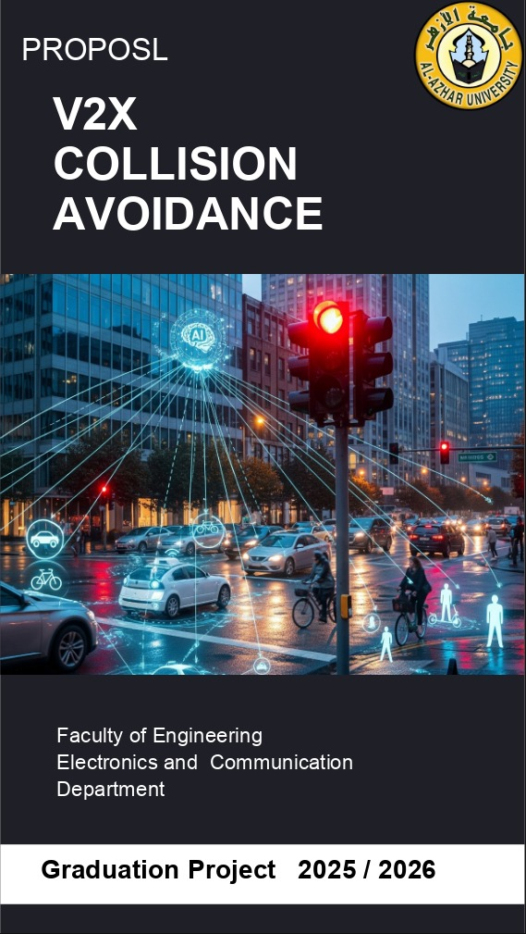

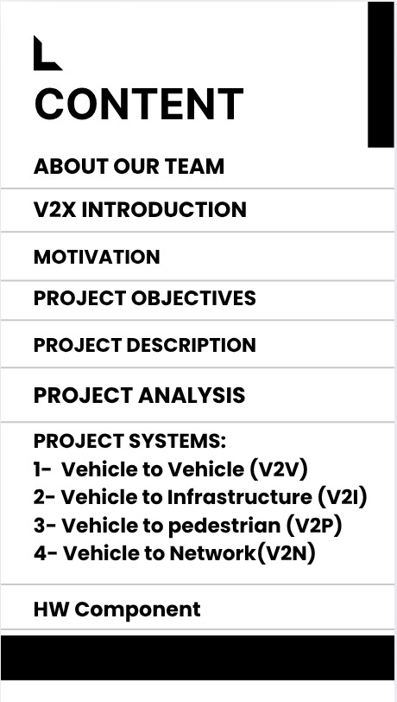

About Our Team:

- Abdallah AbdelMomen Abdallah |  01501899476 |  | 
- Abdallah Saleh Mohamed |  01126740033 |  | 
- Ahmad Gamal Ali |  01006872317 |  | 
- Alaa Hassan Wanas |  01099118093 |  | 
- Amira Atef Roshdy |  01091860768 |  | 
- Aya Gamal Taha |  01287883101 |  | 
- Gamila Adel Mohamed |  01207760389 |  | 
- Asmaa Saad Fouda |  01154756255 |  | 

V2X Introduction:
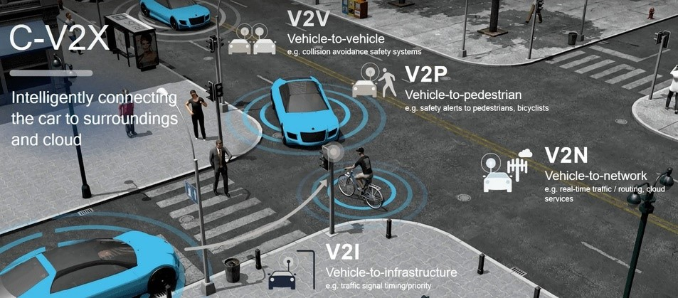
Road safety and transportation efficiency are pressing global challenges, especially in rapidly developing countries like Egypt, where urban expansion and population growth have placed immense pressure on transport systems. Despite ongoing infrastructure improvements, road accidents still cause thousands of fatalities and injuries each year, along with significant economic losses.
Vehicle-to-Everything (V2X) communication offers a promising solution by enabling real-time interaction between vehicles and their surroundings: V2V (vehicle-to-vehicle), V2I (vehicle-to-infrastructure), V2P (vehicle-to-pedestrian), and V2N (vehicle-to-network). These connections support applications such as collision avoidance, adaptive traffic signals, pedestrian safety alerts, and cooperative driving, with studies suggesting accident reductions of up to 80%.
Globally, V2X is gaining momentum for its role in enhancing safety, efficiency, and sustainability. For Egypt, adopting V2X can be transformative—saving lives, reducing economic losses, supporting smart city initiatives, and preparing the path toward autonomous and sustainable mobility.
Motivation:
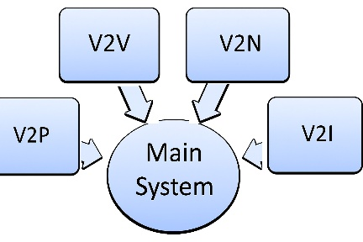
Rapid urbanization and the continuous growth of motor vehicle traffic have resulted in serious transportation challenges such as congestion, frequent accidents, and major socioeconomic losses. Reports by the United States National Highway Traffic Safety Administration (NHTSA) indicate tens of thousands of fatalities and millions of injuries every year, leading to annual economic losses in the hundreds of billions of dollars. Without adopting strict policies and innovative technological measures, these issues are expected to worsen.
To address these challenges, Vehicle-to-Everything (V2X) communication has emerged as a key enabler of safer and more efficient transport systems. By integrating Vehicle-to-Vehicle (V2V), Vehicle-to-Infrastructure (V2I), and Vehicle-to-Pedestrian (V2P) communication, V2X can significantly reduce road accidents, enhance traffic management, and support advanced applications such as cooperative collision warning and intersection safety. V2X is therefore considered a fundamental step toward achieving safer, more secure, and intelligent transportation systems.
Project object:
Our project aims to fulfill the users' needs and expectations by developing an intelligent V2X system that enhances road safety and efficiency. We have envisioned these needs based on real-world challenges in transportation, particularly in high-traffic areas like Egypt. Accordingly, we have planned the project's scope and approach to address them effectively through innovative technologies such as V2X communication and AI integration.
Key visions and needs include:
- Regulating vehicle motion detection: Ensure that every vehicle can detect the motion information (e.g., speed, direction, and position) of other vehicles within a pre-specified range, preventing blind spots and enabling proactive responses (aligned with V2V communication).
- Guaranteeing safety for road users: Provide real-time alerts and protections for pedestrians, cyclists, and drivers to minimize accidents, such as collision warnings and pedestrian crossing notifications (leveraging V2P and V2I).
- Improving traffic efficiency: Optimize traffic flow through intelligent communication with infrastructure (e.g., traffic lights and road signs via V2I/V2N), reducing congestion and travel time.
- Integrating AI for risk prediction: Use artificial intelligence to analyze data in real-time, predict potential hazards, and support decision-making for safer and smarter transportation.
- Addressing local challenges in Egypt: Focus on reducing road accidents in densely populated cities like Cairo, supporting smart city initiatives, and considering local infrastructure limitations for feasible deployment.
This vision guides our project scope, limiting it to a small-scale prototype with simulations, while our approach involves analysis, development, testing, and evaluation to ensure practical impact.
Project Description:
Our project focuses on implementing a V2X communication framework that demonstrates the practical benefits of connected vehicles. The system will allow vehicles to exchange real-time data regarding their speed, position, and movement with nearby vehicles and infrastructure using advanced communication protocols.
The main objective is to simulate a connected environment where vehicles can:
- Continuously share status information.
- Receive alerts about potential hazards or traffic conditions.
- Interact with central servers or cloud platforms for analytics and updates.
By integrating technologies such as GPS, wireless communication, and protocols like MQTT, this project will demonstrate how V2X can significantly improve road safety and traffic efficiency.
Each team member will work on a specific area of V2X (such as V2V, V2I, V2N).
In this proposal, we will provide a detailed explanation of V2N (Vehicle-to-Network) communication, its architecture, features, and the technologies used to achieve it.
Project Analysis:
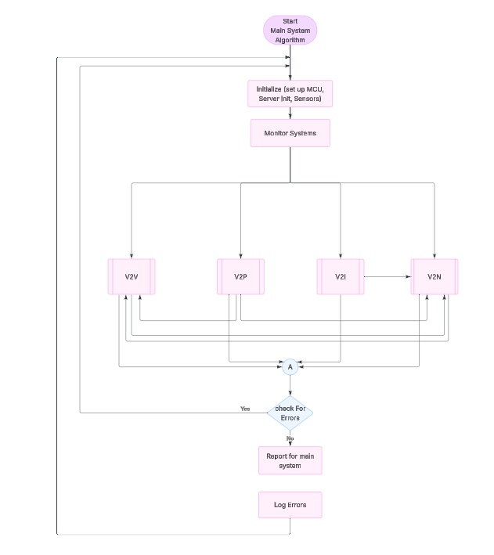
Main System Algorithm:

Project systems:
Specifically handling 4 main Systems:
- Vehicle to Vehicle (V2V)
- Vehicle to Infrastructure (V2I)
- Vehicle to pedestrian (V2P)
- Vehicle to Network(V2N)
1-Vehicle to Vehicle (V2V):
Flow chart:
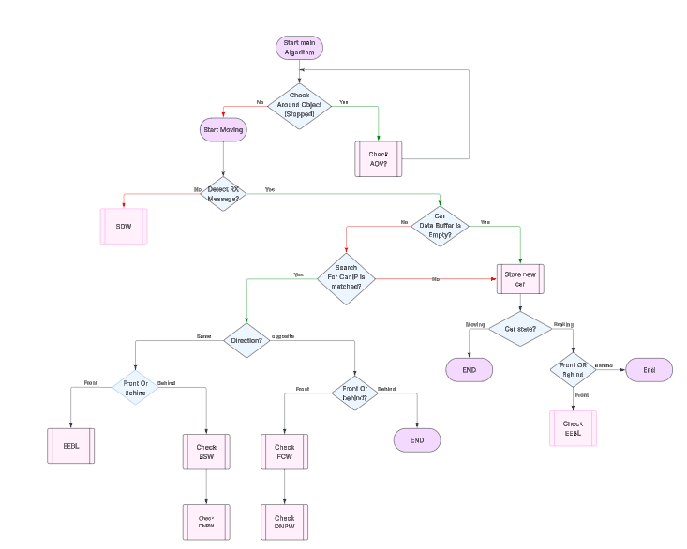

System details:
This System Specifically handling 7 Sub-Systems:
1.1- Electronic Emergency Brake Lights (EEBL)
1.2- Blind Spot Warning (BSW)
1.3- Intersection Movement Assist (IMA)
1.4- Do Not Path Warning (DNPW)
1.5- Forward Collision Warning (FCW (
1.6- Safe Distance Warning (SDW)
1.7- Advanced Driver Assistance System (ADAS)
1.1- Electronic Emergency Brake Lights (EEBL):
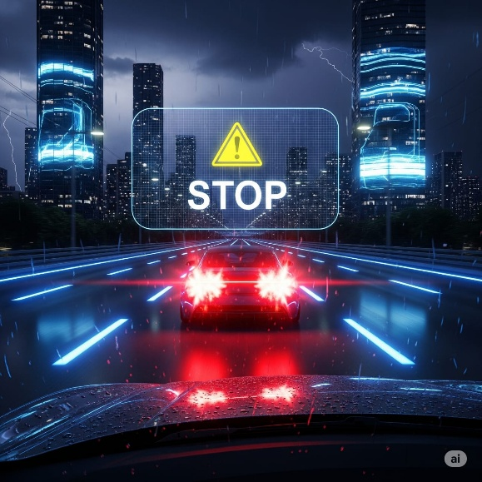
The EEBL system is designed to enhance road safety by providing early warnings of sudden braking events. Using a combination of speed sensors and ultrasonic sensors, the system monitors both the velocity of the host vehicle and the distance to surrounding cars.
Operation Flow (as per flowchart):
When the driver applies sudden braking, the speed sensor detects the rapid deceleration.
The ultrasonic sensor measures the distance to the following vehicles.
If the system detects potential risk of a rear-end collision, it immediately activates:
Local alerts: LEDs and LCD messages warn the driver and passengers.
External alerts: A wireless warning message is sent to nearby vehicles (the "other car") to provide extra reaction time.
If necessary, the system may also command the DC motor to reduce or cut off speed.
This reduces the chance of chain collisions, especially in poor visibility or heavy traffic.

Block diagram:
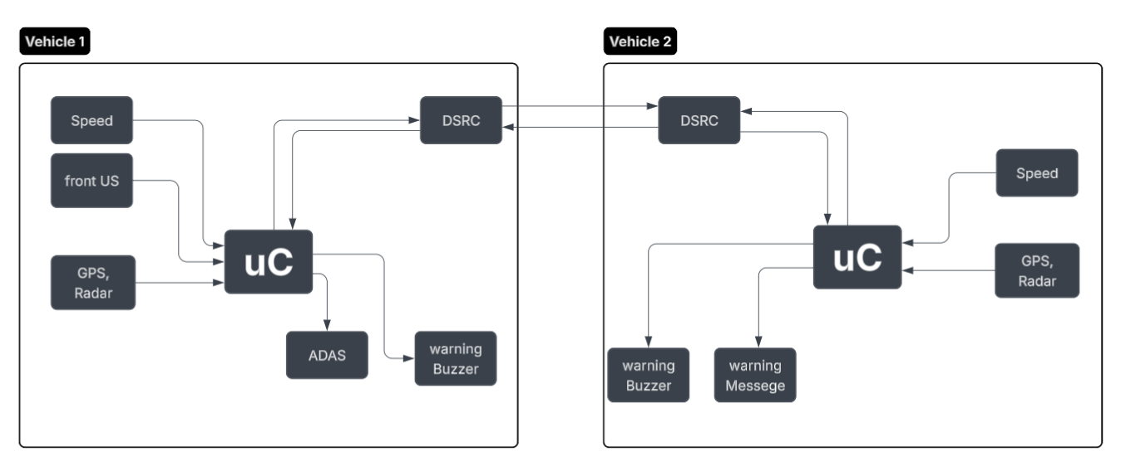

Flow chart:
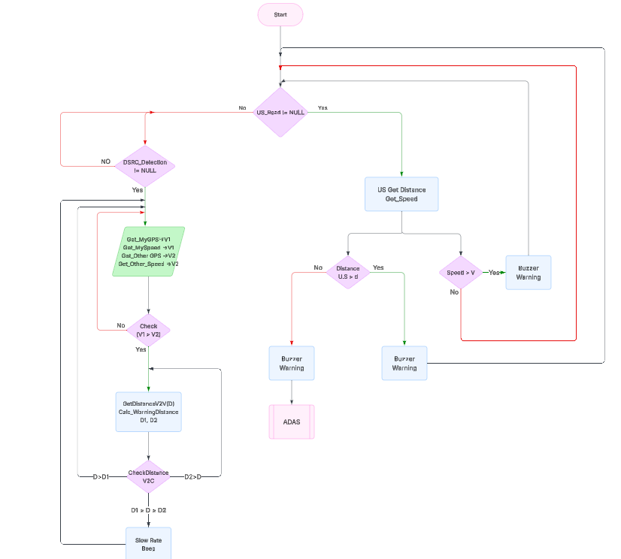

1.2- Blind Spot Warning (BSW):
The BSW system is designed to eliminate the risks associated with the vehicle’s blind spots, which are one of the most common causes of side collisions during lane-changing maneuvers.
Operation Flow:
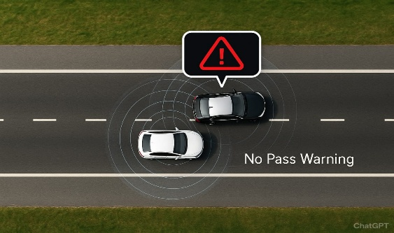
Ultrasonic sensors are mounted on the left and right sides of the vehicle to continuously monitor blind spot areas.
When another vehicle is detected in the blind spot:
A warning LED near the side mirror or on the dashboard is activated.
Optionally, an audio alert can be triggered if the driver attempts to change lanes while the blind spot is occupied.
If no vehicle is detected, the system remains inactive, ensuring no unnecessary distraction.
System Integration:
BSW communicates with the ADAS controller to provide a comprehensive picture of the vehicle’s surroundings.
In case the driver ignores the warning and still attempts to maneuver, ADAS may intervene by suggesting corrective actions (e.g., braking or steering assist).

This system is critical in reducing side-swipe accidents, especially on highways and in heavy traffic conditions.

Block diagram:
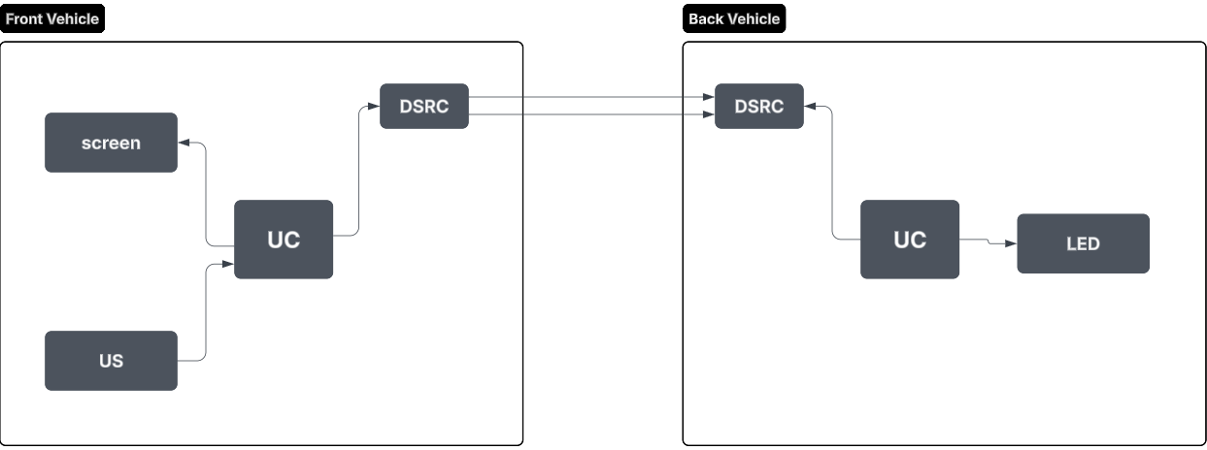
Flow chart:
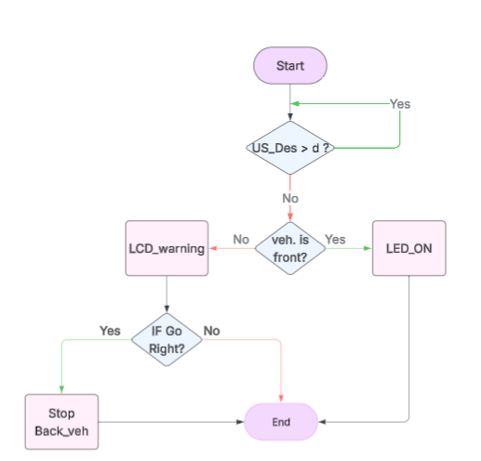

1.3- Intersection Movement Assist (IMA)
The Intersection Movement Assist (IMA) system is designed to prevent dangerous collisions at intersections, one of the most common and fatal accident scenarios. The system relies on V2V communication, where each vehicle approaching the intersection continuously transmits data such as position, speed, and direction using GPS, radar, and DSRC protocols.
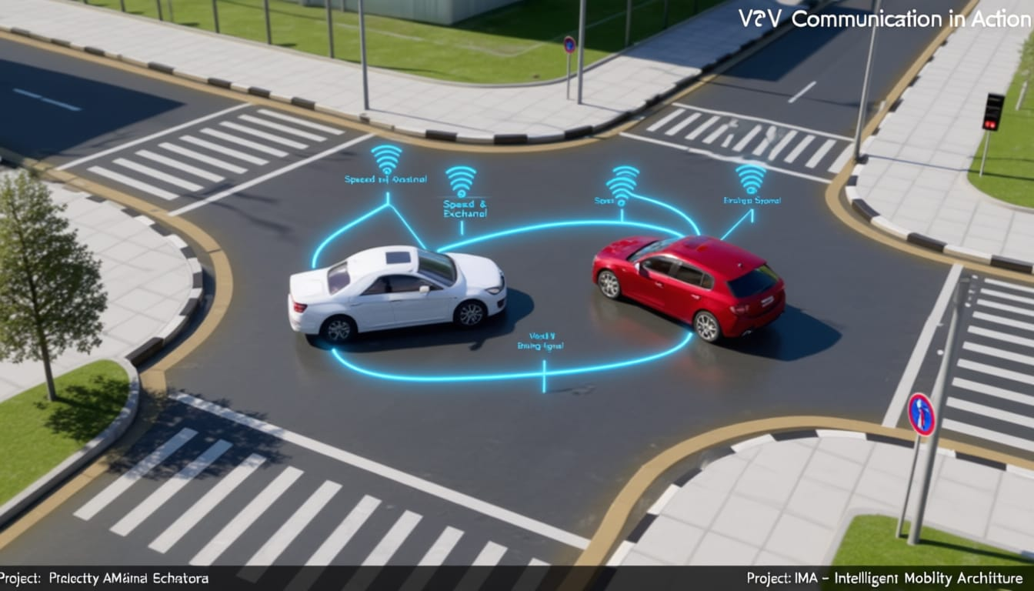
As illustrated in the flowchart, the system begins by detecting vehicles within the intersection zone. If two or more vehicles are approaching with potentially conflicting paths, the system analyzes their relative distance and speed. When the vehicles are more than 20 meters apart, normal operation continues without any alerts. However, if the vehicles are within a 20-meter range, the system calculates collision risk.
If a potential conflict is detected, the slower vehicle automatically receives a delay command, and the driver is alerted via visual and audio warnings (LCD display and speaker). This ensures that one vehicle yields while the other continues, effectively reducing the likelihood of an intersection crash.
Through real-time monitoring and decision-making, IMA enhances road safety by minimizing human error and giving drivers extra reaction time, thereby preventing life-threatening collisions in intersections.
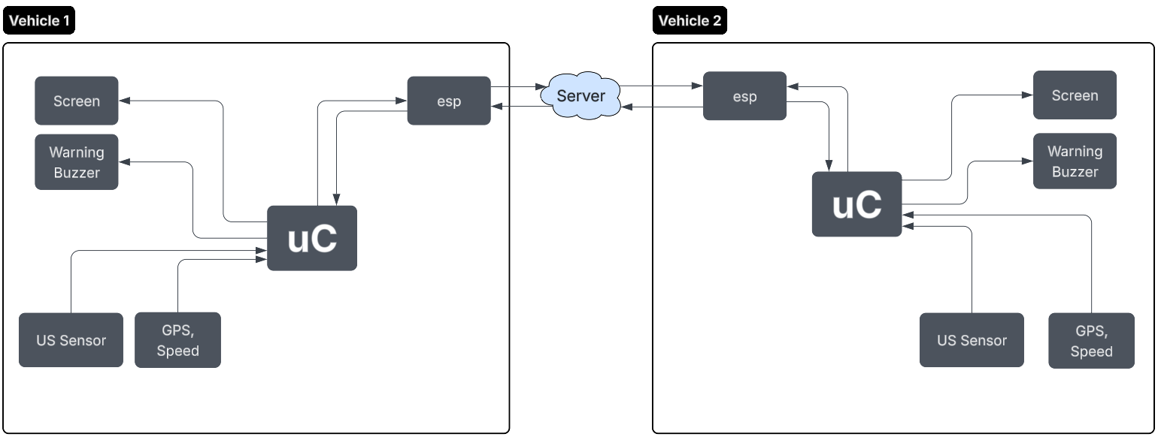
Block diagram:

Flow chart:
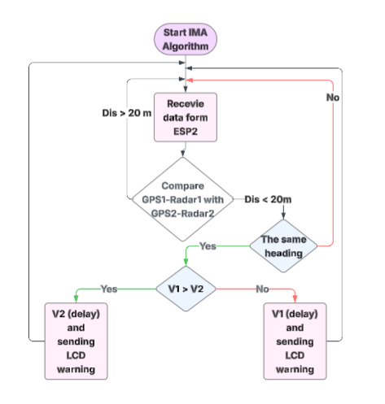

1.4- Do Not Path Warning (DNPW):
The DNPW system aims to prevent unsafe overtaking maneuvers by continuously analyzing road and traffic conditions.
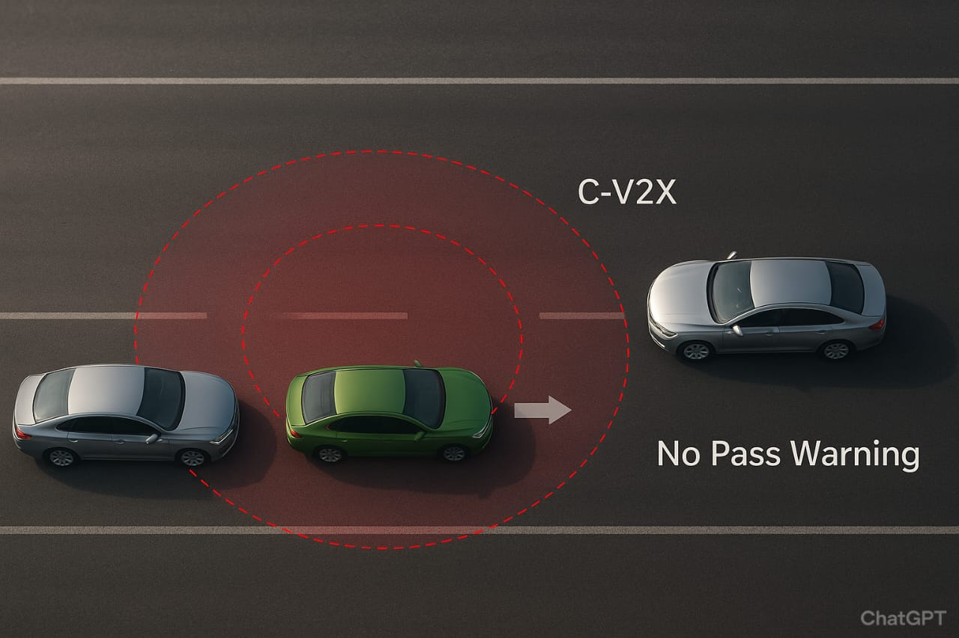
Operation Flow (as per flowchart):
The system collects data from:
Speed sensor → vehicle’s velocity.
Ultrasonic sensors → distance from vehicles in the same or opposite lane.
The DNPW processes this data and evaluates whether overtaking is safe.
If overtaking is deemed unsafe:
The LED indicator changes state to alert the driver.
The LCD displays a warning or a "clear" message.
A warning signal may be transmitted to surrounding vehicles.
If the danger is critical, the system may activate the DC motor to stop or limit the car’s movement.
This proactive check reduces head-on collision risks and prevents dangerous lane-change decisions.
Block diagram:
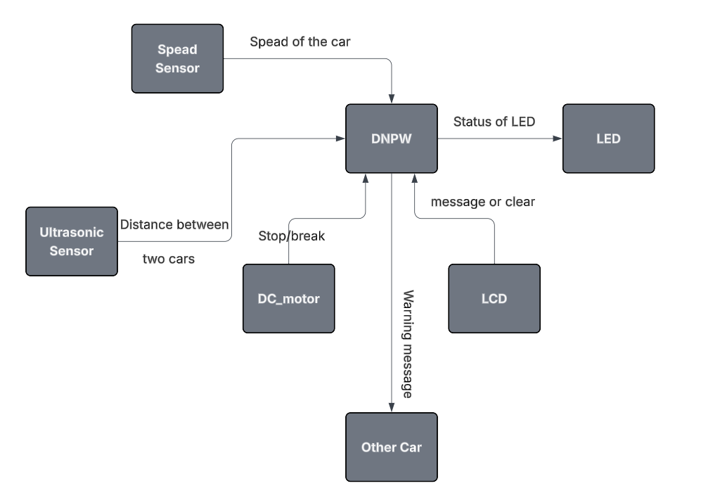

Flow chart:
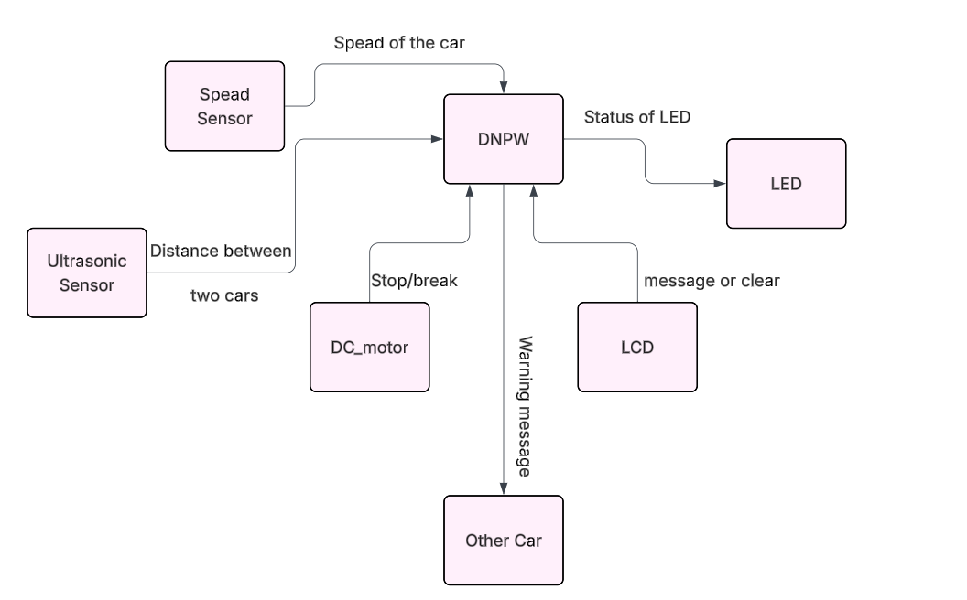

1.5- Forward Collision Warning (FCW)
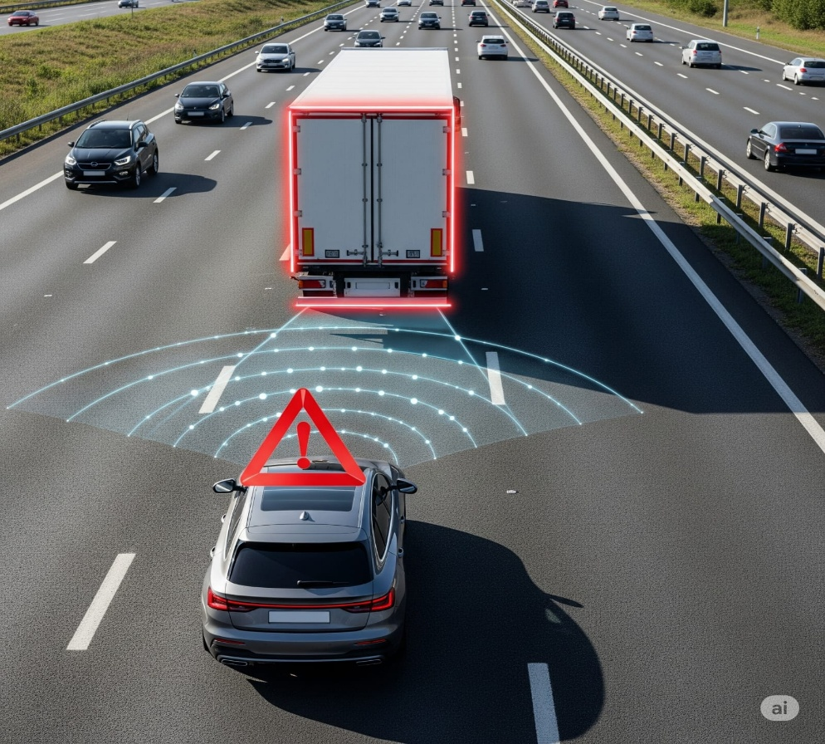
The Forward Collision Warning (FCW) system is designed to prevent rear-end collisions, which are among the most frequent and dangerous road accidents. The system continuously monitors the area in front of the vehicle using radar, ultrasonic sensors, and cameras to detect other vehicles, pedestrians, or obstacles.
Based on the flowchart, the system begins by identifying objects within a defined safety range. If the distance between the host vehicle and the object ahead is greater than 10 meters, normal driving continues without intervention. However, when the detected object is within 10 meters, the system immediately issues a visual and audio warning through the LCD display and speaker to alert the driver.
If the driver does not react and the distance continues to decrease to a critical threshold, the system escalates the response by activating the ADAS braking mechanism, reducing speed or stopping the car completely to prevent collision.
By combining real-time sensing, warning messages, and automatic intervention, the FCW system reduces the risk of crashes caused by distracted driving, tailgating, or sudden stops, ultimately improving road safety and saving lives.
Block diagram
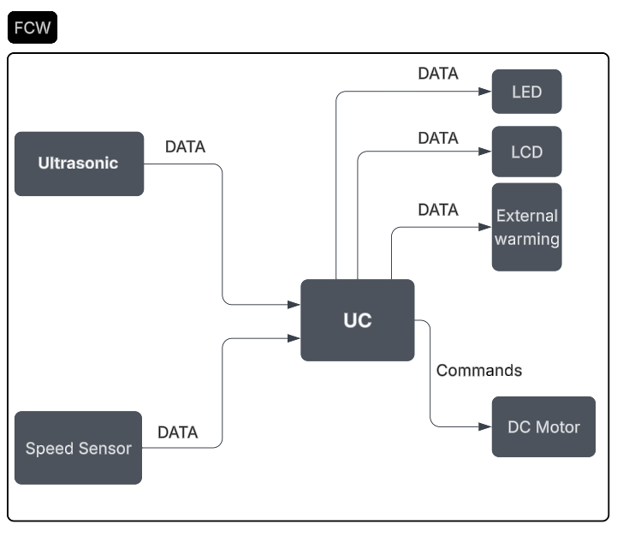

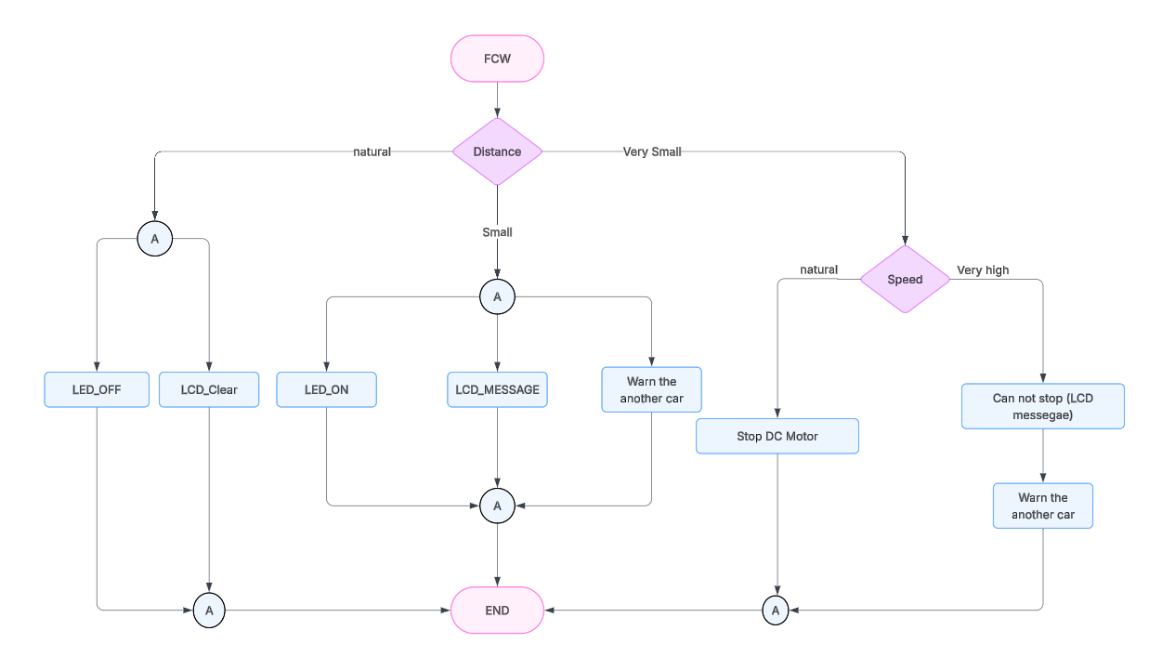
Flow chart:

1.6 Safe Distance Warning (SDW)
The SDW system ensures that a safe buffer is always maintained between the host vehicle and surrounding obstacles.
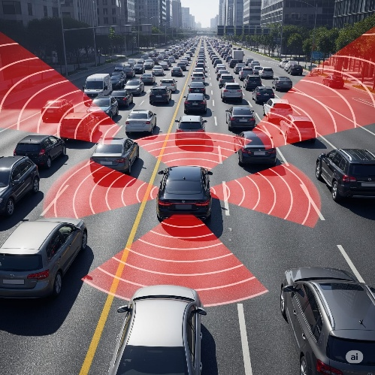
Operation Flow (as per flowchart):
Multiple ultrasonic sensors (front, rear, left, right) continuously measure the distances around the vehicle.
The system checks if any object is within the warning threshold:
If safe: No action is taken.
If within warning distance: A visual or audible alert (warning lights/messages) is generated.
If within dangerous distance (critical threshold): The system immediately communicates with the ADAS to take corrective action.
Depending on the scenario, SDW may trigger braking or steering corrections.
This guarantees safer driving in congested roads, intersections, and high-speed environments by preventing sudden close encounters.

Block diagram:
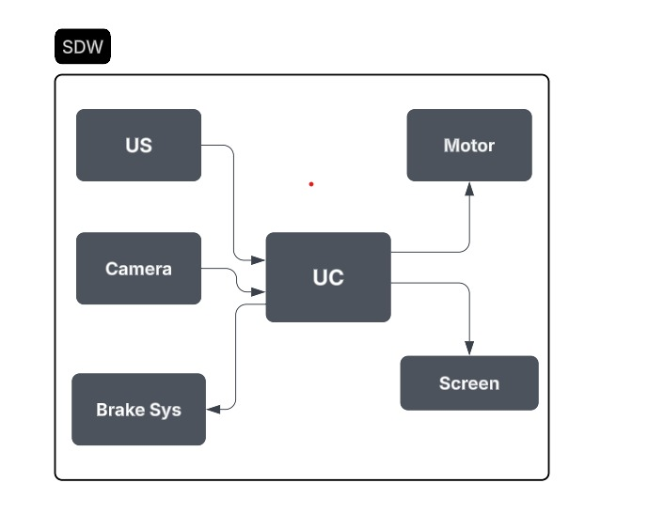

Flow chart:
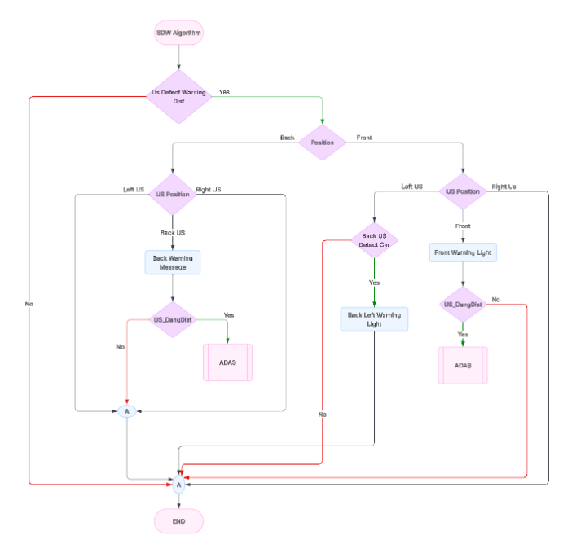

1.7 Advanced Driver Assistance System (ADAS):
The ADAS system acts as the central intelligence unit, integrating data and responses from EEBL, DNPW, and SDW.
Operation Flow (as per flowchart):
ADAS starts by checking the vehicle’s direction of movement.
It then evaluates surrounding obstacles using input from all sensors.
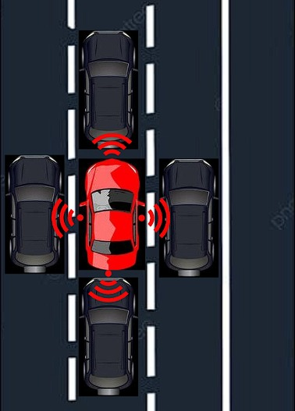
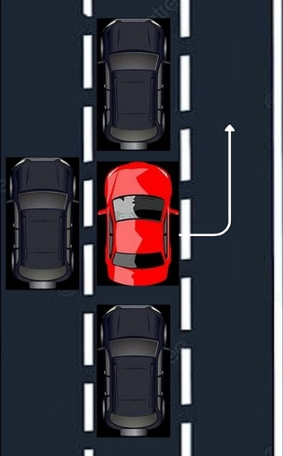
If obstacles are detected:
If clear in all directions: Sends message to all subsystems to proceed safely.
If blocked in certain directions: ADAS makes a decision:
Example: If front is blocked, but right is free → "Go Right".
If left is free → "Go Left".
If all directions are blocked → issue "Brake" command.
ADAS also communicates with other vehicles via message exchange to synchronize safety maneuvers.
This makes ADAS the "brain" of the system, ensuring coordinated, autonomous responses in real-time to avoid accidents.
Block diagram:
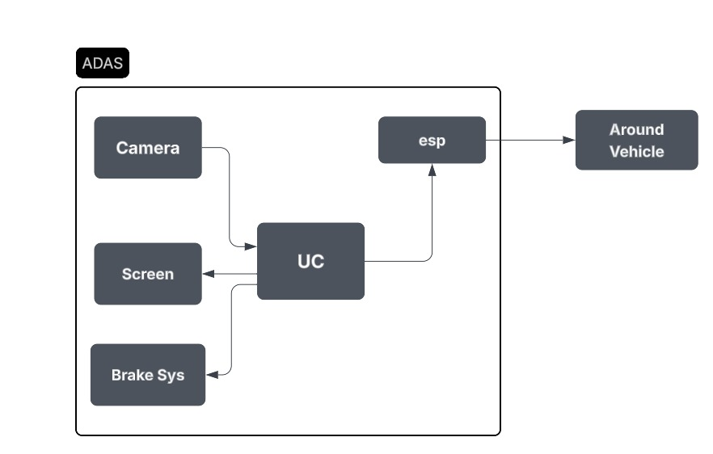

Flow chart:
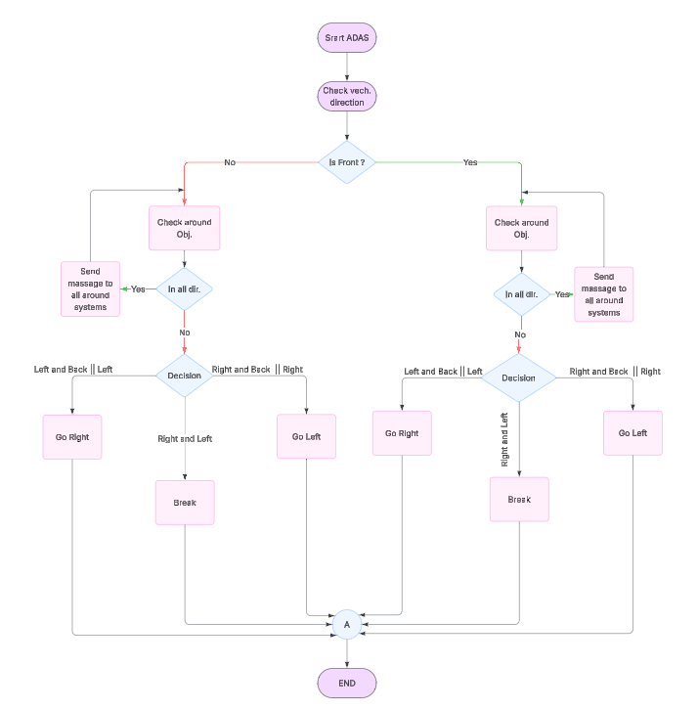

2) Vehicle to Infrastructure (V2I):
Vehicle-to-Infrastructure (V2I) communication is a crucial component of the V2X ecosystem. It enables vehicles to wirelessly exchange data with traffic lights, road signs, and roadside sensors. This technology helps optimize traffic flow, improve road safety, and assists drivers and infrastructure operators in making better decisions.
Suggested image: A car communicating with a smart traffic signal or roadside sensor.

Why V2I? (Previous Challenges):
Before V2I, vehicles operated mostly in isolation with limited communication capabilities.
Drivers relied on:
- Static navigation maps without real-time updates.
- Manual traffic reports or radio announcements for incidents.
- Lack of coordination between vehicles and infrastructure, leading to congestion and slow incident response.
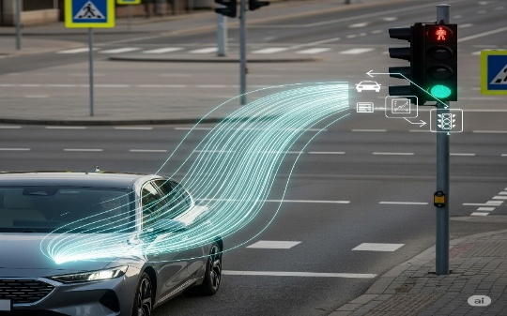
Problems with previous systems:
- No real-time traffic awareness.
- Poor emergency response capability.
- Inefficient route planning causing delays.
How V2I solves these issues:
- Real-time data exchange through smart infrastructure.
- Instant notifications about hazards and traffic conditions.
- Dynamic route adjustment for optimal travel.
Block diagram:
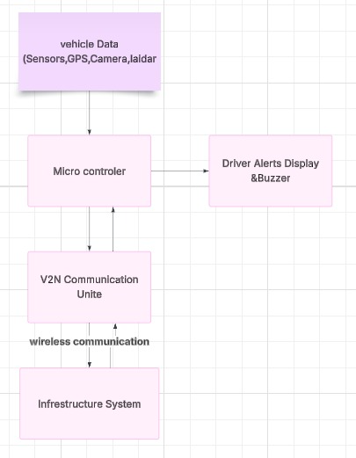

Flow chart:
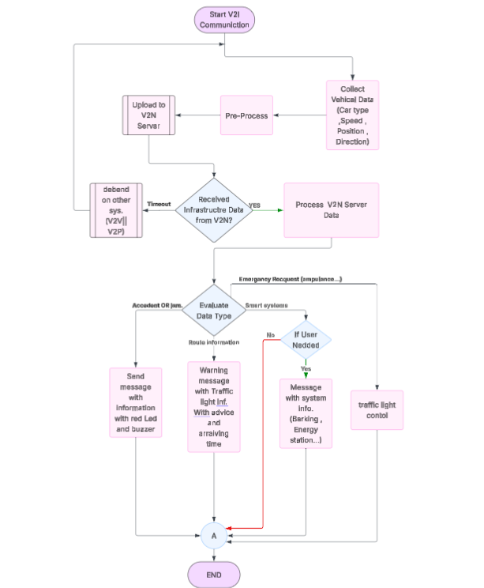

3) Vehicle to pedestrian (V2P):
Vehicle-to-Pedestrian (V2P) communication is considered one of the most promising technologies for enhancing the safety of vulnerable road users. However, relying solely on handheld devices (such as 5G-enabled smartphones or DSRC units) faces practical challenges, since many pedestrians do not consistently carry such devices. To overcome this limitation, recent research has focused on leveraging computer vision and smart sensing technologies to detect and interact with pedestrians in real time.
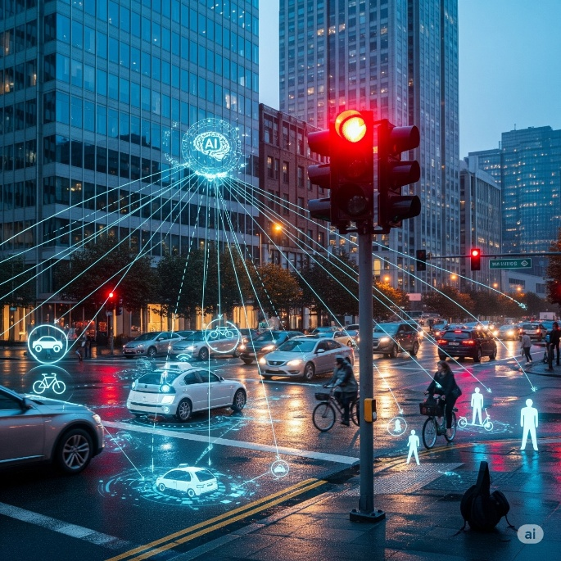
On one hand, vision-based systems utilizing traffic cameras and deep learning models have been developed to detect pedestrians at signalized intersections and generate Personal Safety Messages (PSMs) with update rates as fast as every 100 milliseconds. These systems demonstrated superior accuracy in estimating pedestrian location and velocity compared to conventional DSRC-enabled handheld devices, enabling the generation of timely alerts to prevent potential collisions.
On the other hand, more advanced frameworks have been proposed that fuse camera data with LiDAR sensors to achieve more robust pedestrian detection and tracking in autonomous driving environments. This approach converts LiDAR streams into depth images and employs deep neural networks to identify pedestrians in both RGB and depth data, while sensor fusion techniques such as the Kalman Filter and optical flow algorithms enable reliable multi-pedestrian tracking with high accuracy.
The findings from these studies indicate that vision-based and multi-sensor fusion approaches provide effective and reliable alternatives for V2P communication, capable of meeting the accuracy and latency requirements of safety applications in connected and autonomous vehicle environments. Ultimately, such systems pave the way for safer and smarter transportation networks.

Block Diagram:
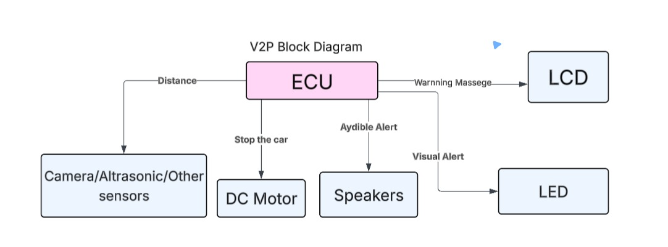
Flow chart:
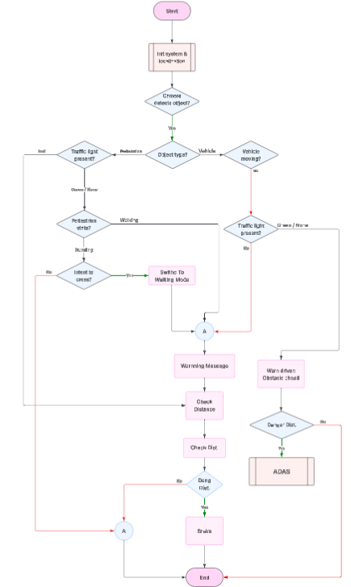

4) Vehicle to Network (V2N):
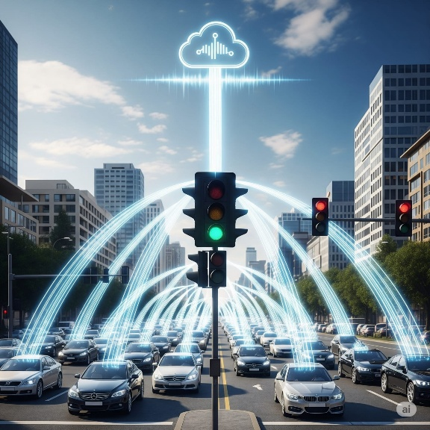
Vehicle-to-Network (V2N) communication is a core component of the V2X ecosystem, enabling vehicles to connect with cloud servers or edge networks via cellular technologies such as 4G, 5G, or through Wi-Fi-based solutions. V2N allows vehicles to access real-time data from traffic management systems, navigation services, and IoT platforms. This communication is essential for enabling advanced features like Traffic Management, accident, hazard notifications, over-the-air updates, etc.
Why V2N? (Previous Challenges)
Before V2N was introduced, vehicles operated mostly in isolation with limited communication capabilities.
Drivers relied on:
Static navigation maps that did not update in real time.
Manual traffic reports or radio announcements for accident updates.
Lack of coordination between vehicles and infrastructure, leading to traffic congestion and delayed responses to incidents.
Problems with Old Systems:
No real-time traffic awareness:
Drivers could not adapt to sudden congestion or accidents.
Poor emergency response: Lack of quick alerts for hazardous conditions.
Inefficient route planning: Drivers often encountered delays without alternative route suggestions.
How V2N Solves This:
Real-time data exchange via a central server.
Instant hazard and traffic notifications to all connected vehicles.
Dynamic route adjustments based on live conditions (features).
Block diagram:
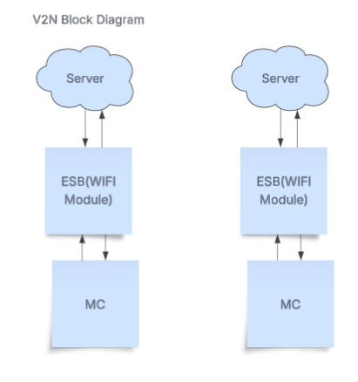

Flow Chart (V2N):
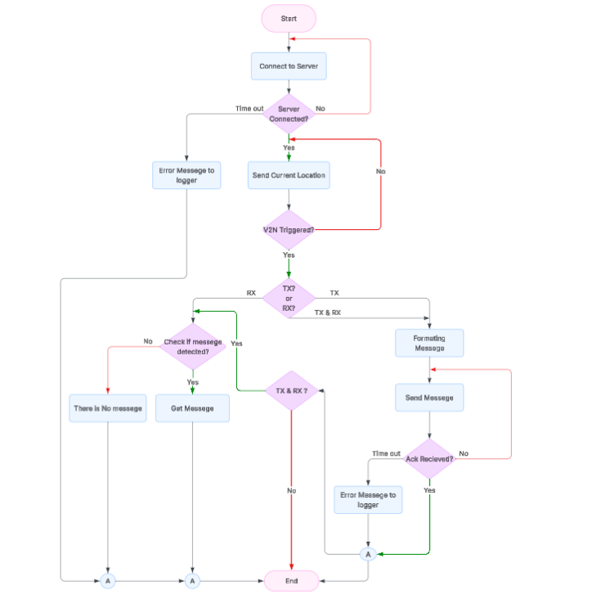

Flow Chart (Server):

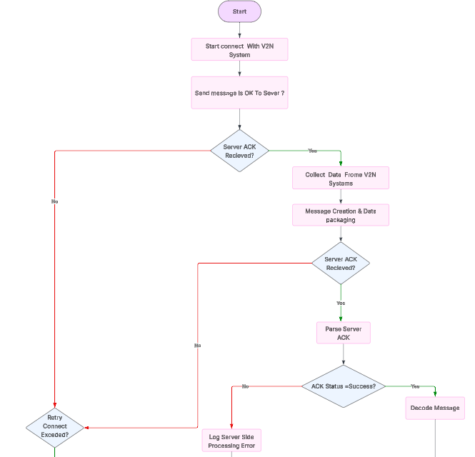

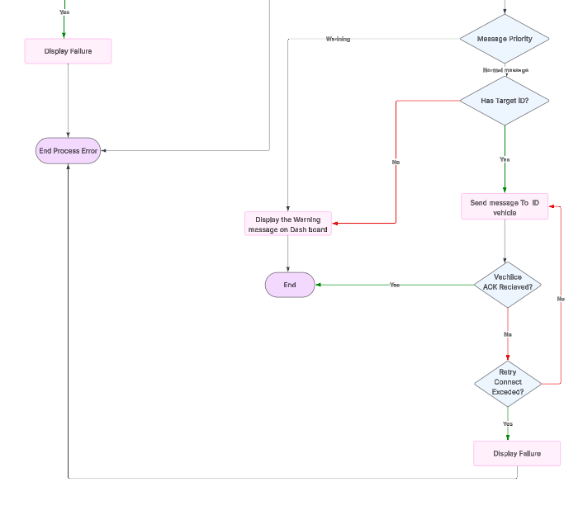
HW Components:

Controllers | Sensors
ESP32 | GPS Module
STM32 (Raspberry Pi if needed) | Buzzer / Speaker
 | Ultrasonic Sensor
 | Camera Module
 | Wheel Speed Sensor
 | Other Components
 | DSRC/C-V2X Module
 | LED Indicators
 | LCD/OLED Display

